|  |  |  |
| --- | --- | --- |
| Product Catalogue | Pin header |  |
| Spacing | 2.54mm |  |
| Total number of pins | - |  |
| Number of rows | - |  |
| Pin structure | - |  |
| Line spacing | 2.54mm |  |
| Installation type | Straight cutting |  |
| Round needle / guide pin | - |  |
| Rated current | - |  |
| Rated voltage | - |  |
| Coil length | - |  |
| Plug height | 2.54mm |  |
| Contact material | Phosphor bronze |  |
| Contact coating | - |  |
| Color | Black |  |

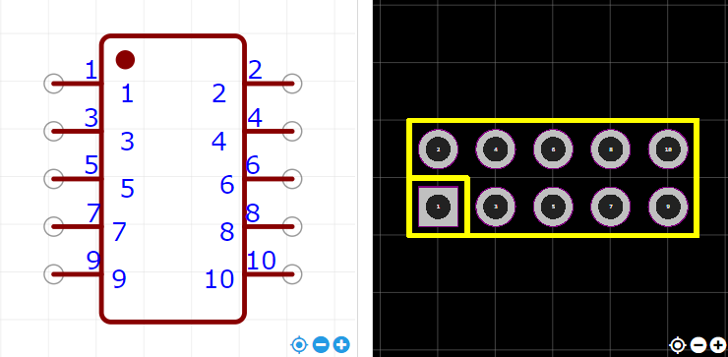

<https://item.szlcsc.com/214380.html>